Introduction to NAVIANCE
Naviance is a powerful tool for educators, students, and families to explore careers and colleges. It allows users to set and track academic goals, write resumes, and communicate with academic advising personnel. As an introductory activity, students will log-in and complete a very short survey designed to help University High School administration identify themes related to student absenteeism. The following should help you to instruct students where to go to log-in and where to look so that they can access the attendance survey.
- Have student search NAVIANCE

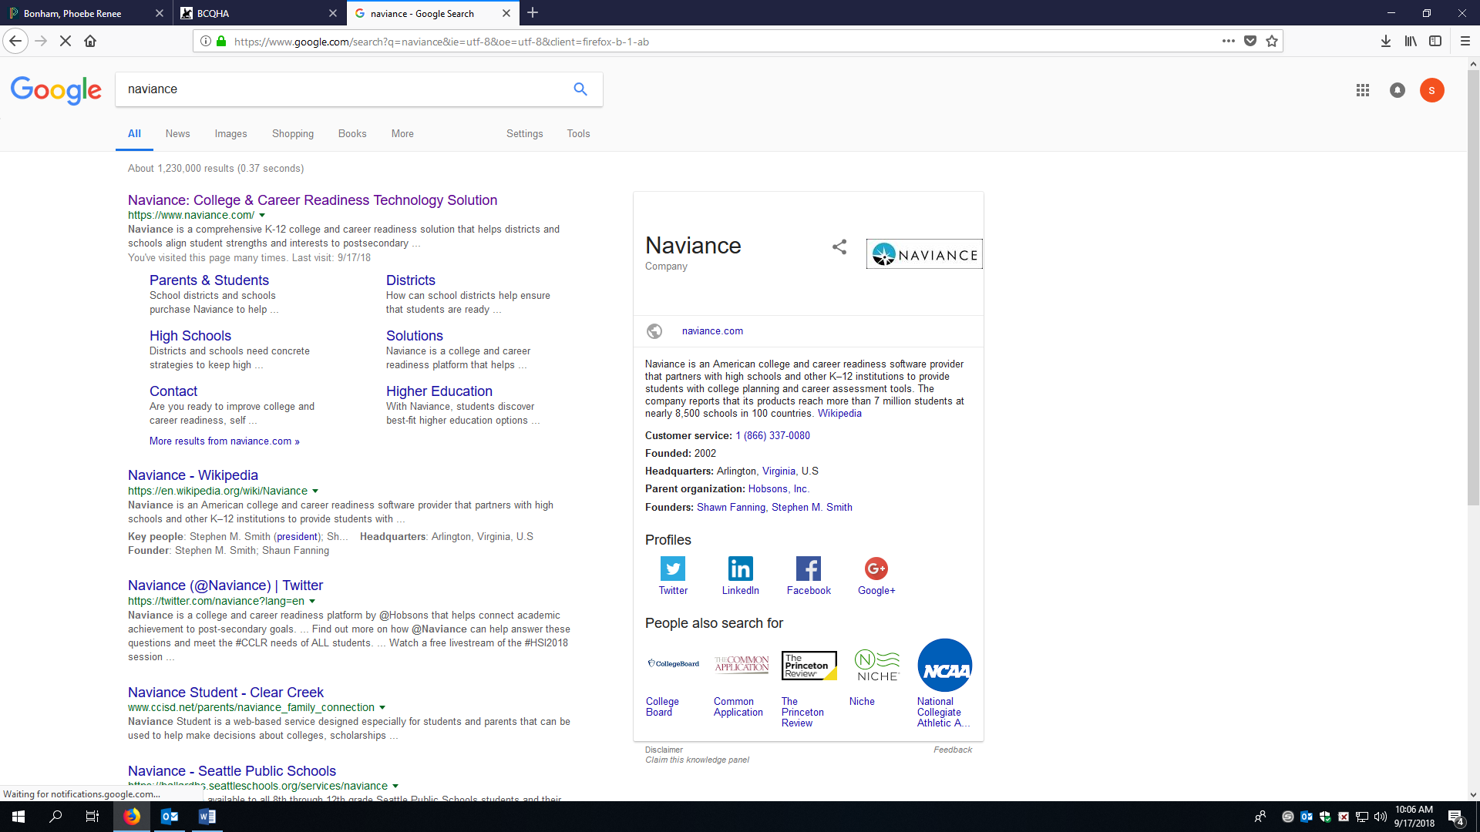

- Click on Naviance: College & Career Readiness Solution
- The Naviance homepage will look like this:
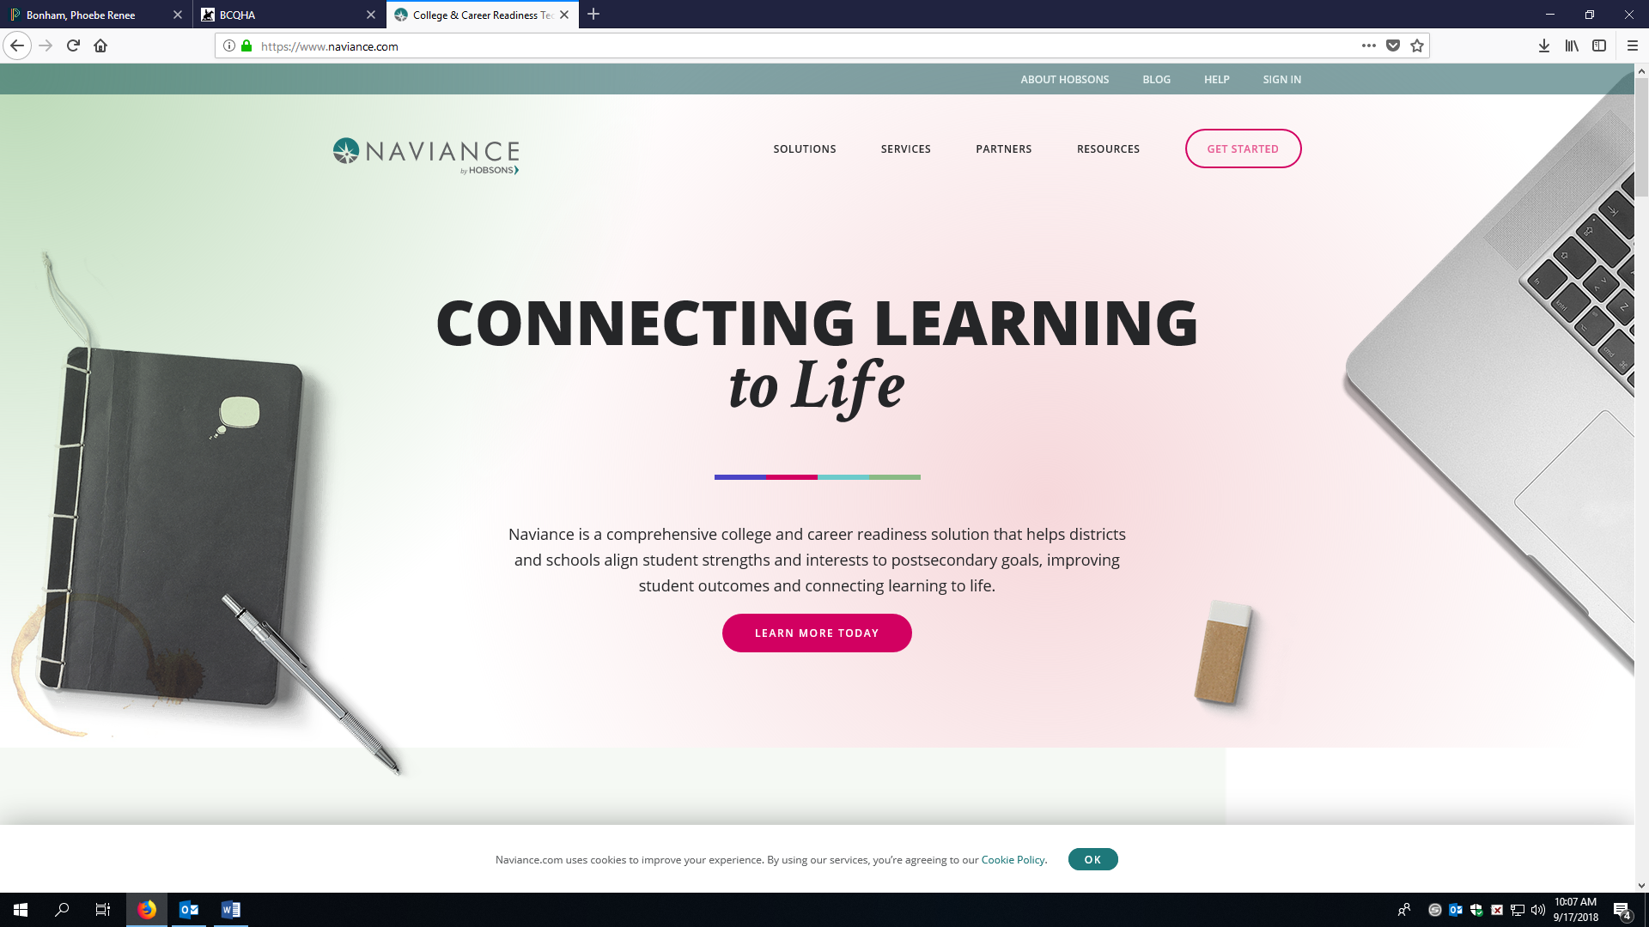
- Click SIGN IN, then Students & Families
- Student will immediately be asked to enter a zip code. They will use 88201 and then click UNIVERSITY HIGH SCHOOL. The next screen will look like this:

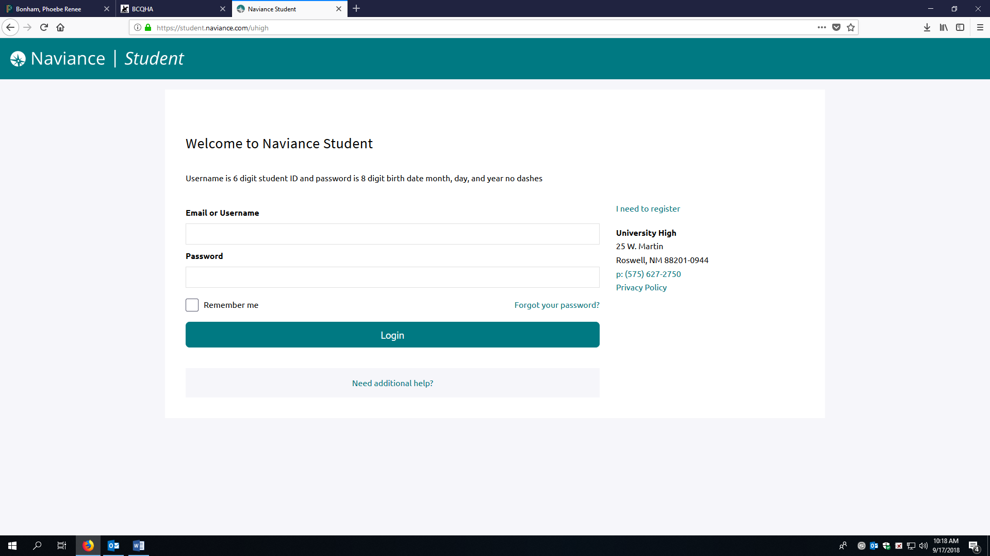

- Student log-in credentials are: username is 6 digit student ID and password is 8 digit birth date month, day, and year no dashes.

- This is the welcome page your students will see.
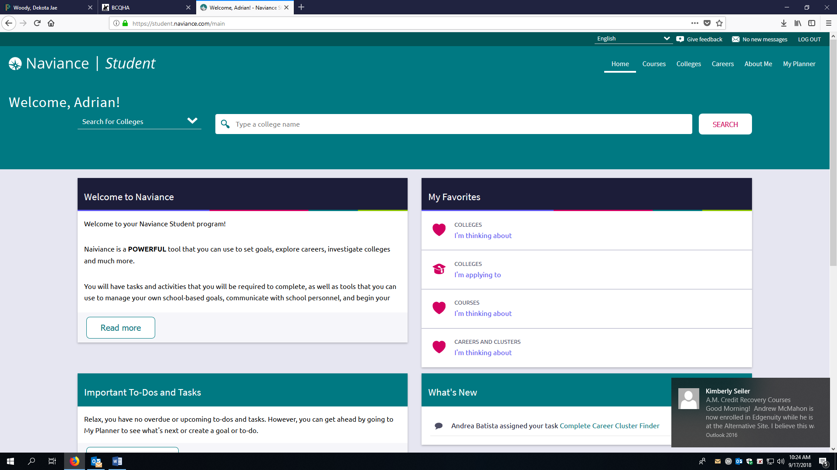
- Scroll down to bottom left and click on the Blue Box, Complete the lessons by clicking on Get Started.
- Once you have completed ALL the lessons, exit and go back to the Main Page.
- Check the section under tTo-Do-List.
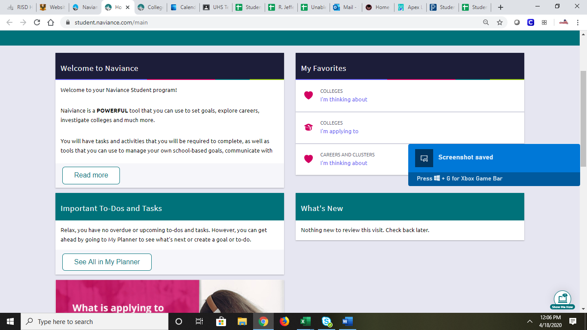

- Once students have completed all the tasks, please have them logout.

